UDID Checker

How to guide

By Google Siri Server (byrnecal)

**NOTE: IF YOU ARE USING THIS WITH A PUBLIC WITH A DOMAIN MAKE SURE PORT 80 (HTTP) IS FORWARDED TO YOUR SERVER IN YOUR ROUTOR OR MODEM OR THIS WILL NOT WORK**

**Step 1 (Making a Database)**

1. I use phpmyadmin to install this go to terminal and type or copy and paste the following : sudo apt-get install phpmyadmin
2. While installing make sure you select webserver as apache!!
3. Follow the rest of the installation process
4. Set up your password as your main login password for ubuntu!
5. We now need to delete the index.html file in /var/www using the following commands
6. cd /var/www
7. rm index.html
8. Next we need to move the php files to hear using the following
9. cp –r /usr/share/phpmyadmin /var/www
10. Close out of terminal
11. Open your browser and type 127.0.0.1/phpmyadmin
12. You should be greeted with the phpmyadmin login screen
13. 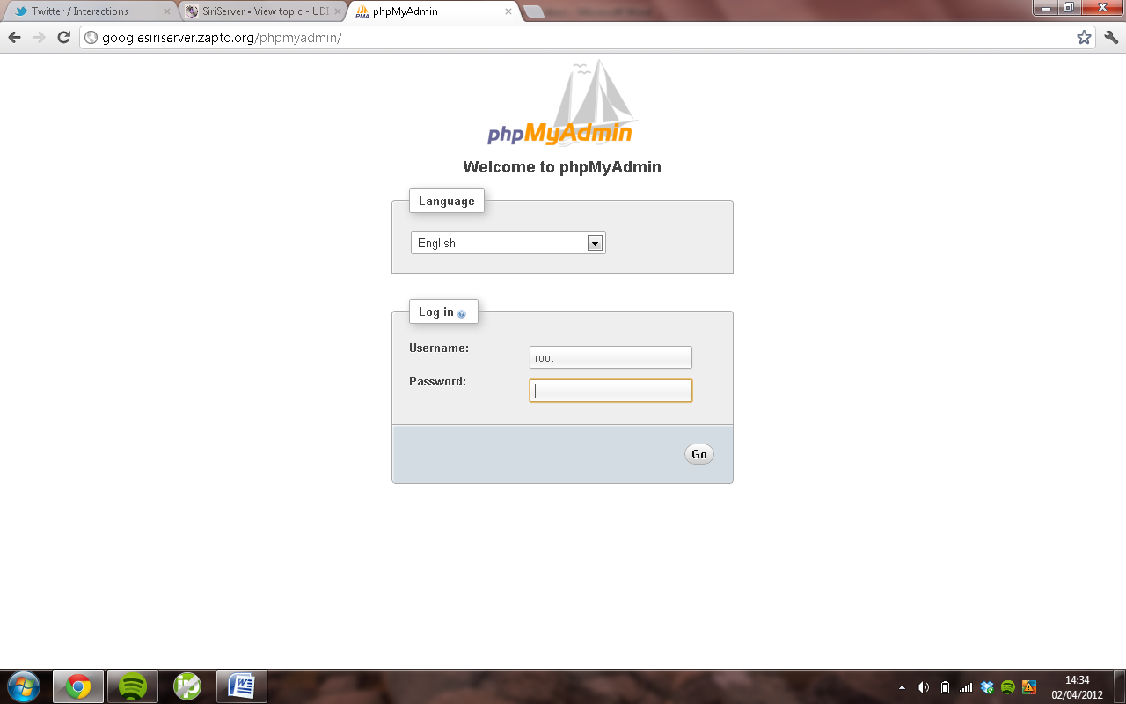
14. Now you want to login with username as root and password as YOUR UBUNTU LOGIN PASSWORD!!
15. Next we want to create a database called auth
16. To do this click on databases and type the name auth and click create
17. 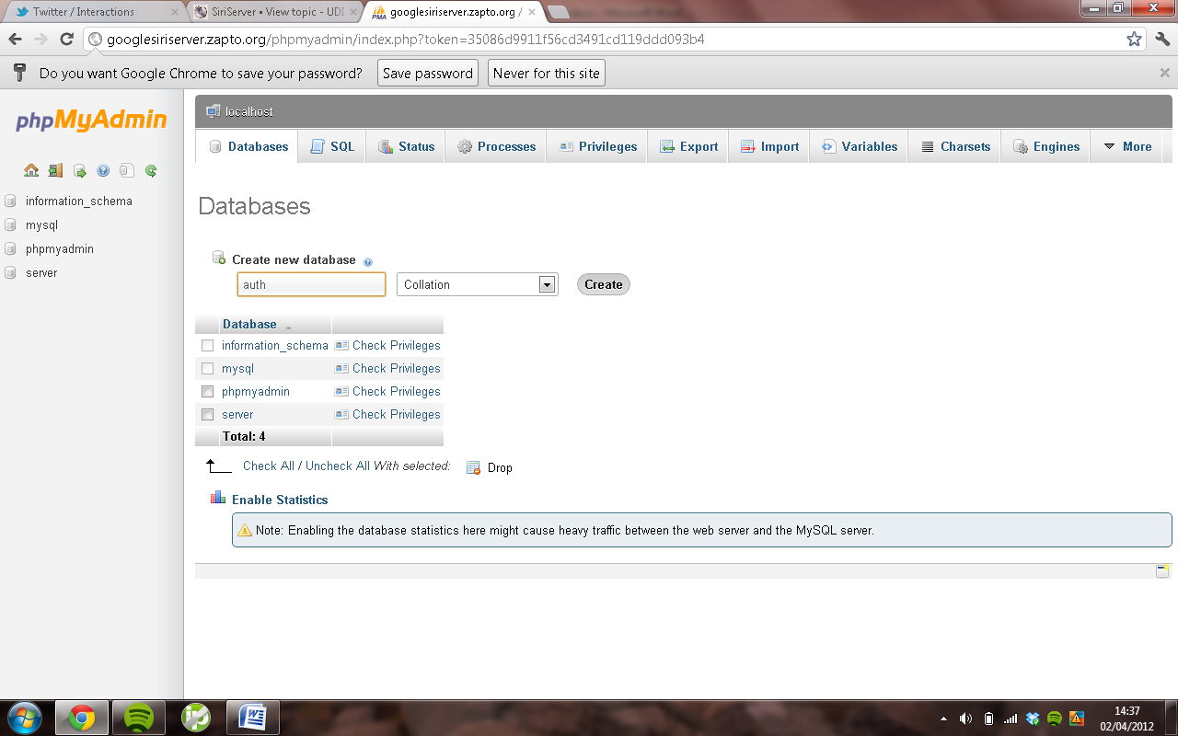
18. now click on auth in sidebar
19. now you want to create a table called users
20. with number of columns as 1
21. Once you press create a screen will pop up like the one below and copy all the information exactly !
22. 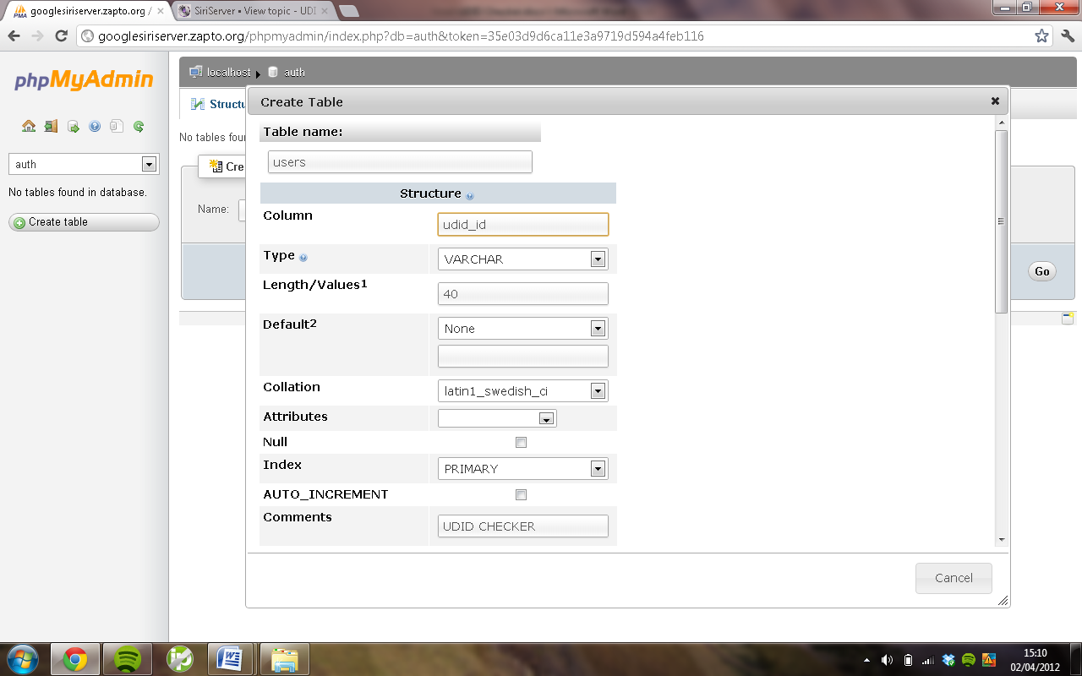
23. Once you have done all that click in column and press enter and it will create the table and the column.
24. Then in auth you click insert and in value type the udid you want to add and do this for all of them
25. 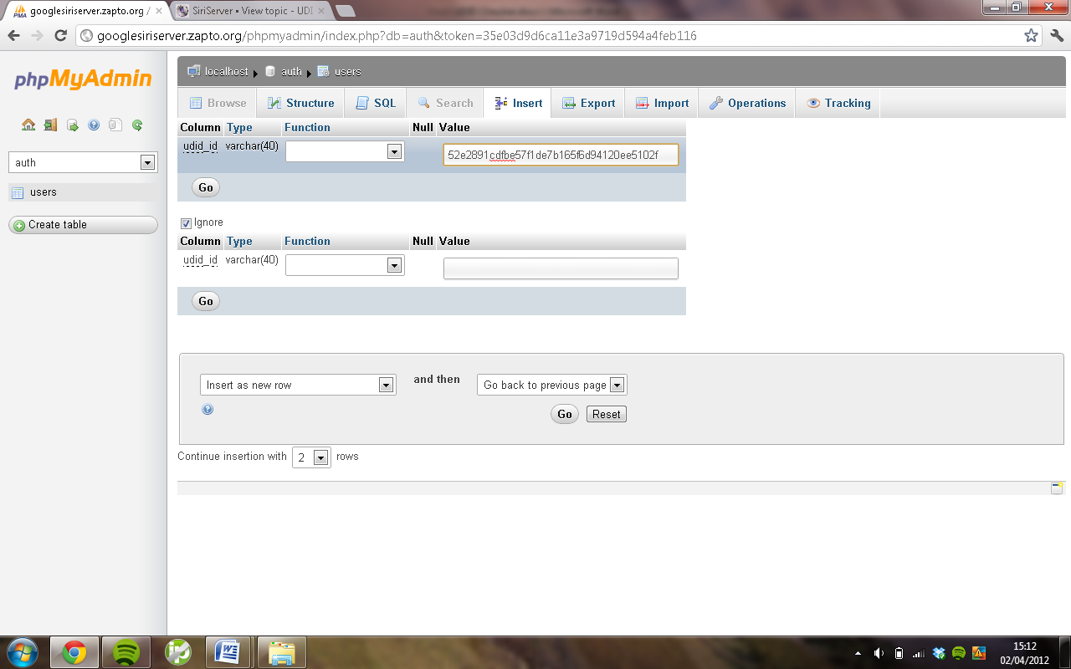
26. Everytime you want to add a udid just go to 127.0.0.1/phpmyadmin and then login and go to auth then insert and type another udid in and do this for every udid

**Setting up the files for use!**

1. Now move all the contents from the file you downloaded and extracted
2. Move them to /var/www by copying and pasting them so your /var/www folder looks like this
3. 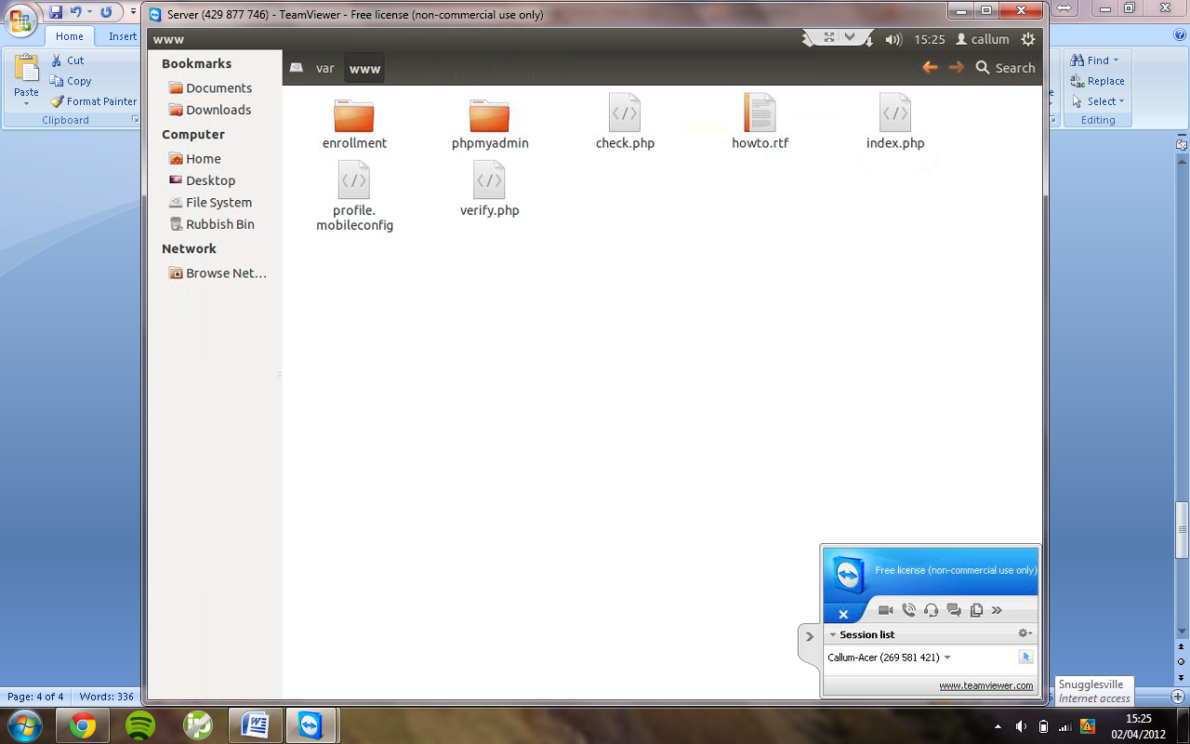
4. **Now we need to configure the files like so**
5. **OPEN ALL THE FILES NEXT IN TEXT EDITOR!**
6. **Now we need to open verify.php so open it and at the top where its says “PASSWORD HEAR!” delete that but still leave the speech marks and put your password in and save the file**
7. 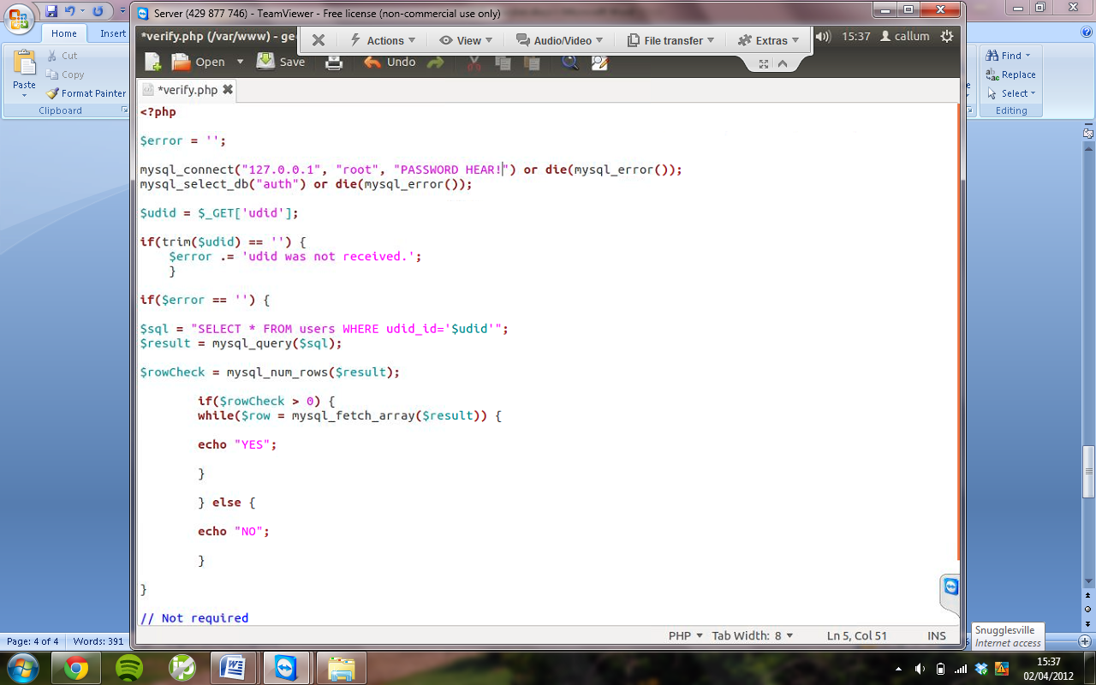
8. **Next open profile.mobileconfig using text editor by right clicking and open with text editor.**
9. **Change where it says PUT YOUR DOMAIN OR IP HEAR to your domain like your server domain or your ip address and save the file.** 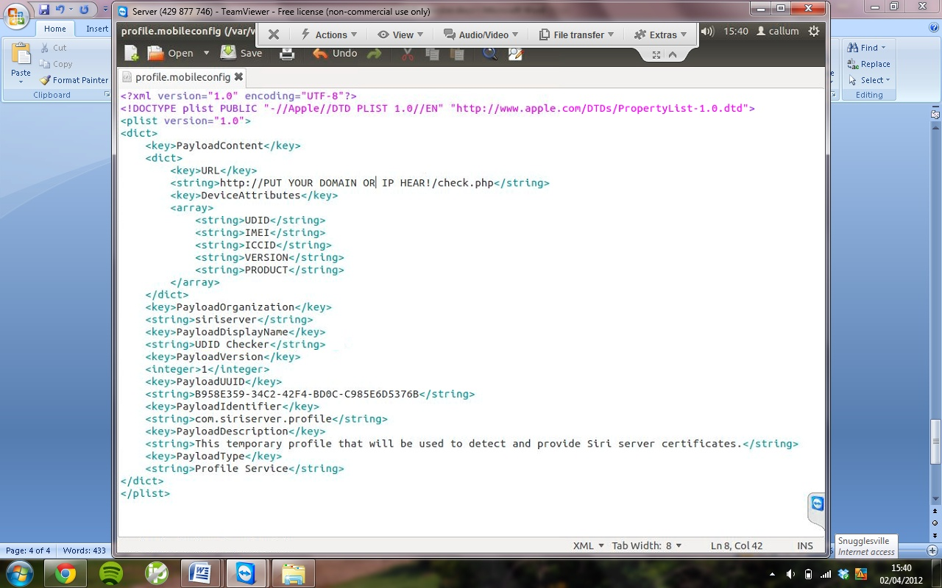
10. **Now open check.php again in text editor and right at the bottom where it says Your domain or ip hear put your domain address or ip.**
11. **Save the file and exit out of it**
12. **Next put a COPY! of your ca.pem file in the enrolment Folder**
13. **Now open index.php in the enrolment folder using text editor and change where it says your domain or ip hear and put your domain or ip there and save the file**
14. **Restart your server computer**
15. **Make sure you have added the devices udid or you will get access denied your udid is not in our database.**
16. **Test it out go to your domain or ip address of the server and you should be greated with the UDID Checker cert and then if your udid is in the database it should then say click hear to download cert.**
17. **Thats it !!**

**I have wrote this guide out of my own time and i hope you like it as it has every single step and if you need help let know and i will be able to help you**